29.41: a) For magnetic fields less than the critical field, there is no internal magnetic field, so:
Inside the superconductor: 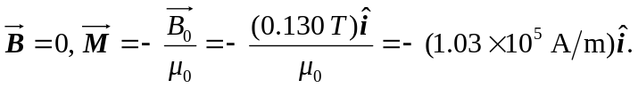
Outside the superconductor: 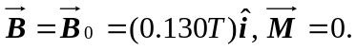
b) For magnetic fields greater than the critical field, 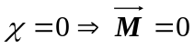 both inside and outside the superconductor, and 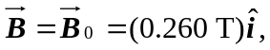 both inside and outside the superconductor.

